#include <stdio.h>
#include <stdlib.h>
#include <string.h>
#include <time.h>

#define MAX_TASKS 50
#define MAX_LENGTH 100
#define MAX_SUBJECTS 10

// Structure definitions
typedef struct {
char description[MAX_LENGTH];
int completed;
char deadline[20];
} Task;

typedef struct {
char subject[50];
float grade;
int credits;
} Course;

// Global variables
Task tasks[MAX_TASKS];
int taskCount = 0;

Course courses[MAX_SUBJECTS];
int courseCount = 0;

// Function prototypes
void displayMenu();
void taskManager();
void addTask();
void viewTasks();
void completeTask();

void pomodoroTimer();

void gradeCalculator();
void addCourse();
void calculateGPA();
void viewCourses();

void studyTracker();

void quickNote();
void viewNotes();

void saveData();
void loadData();

void clearScreen();
void pressEnterToContinue();

// MAIN FUNCTION
int main() {
int choice;

loadData();

while (1) {
displayMenu();
printf("Enter your choice: ");
scanf("%d", &choice);
getchar();

switch (choice) {
case 1: taskManager(); break;
case 2: pomodoroTimer(); break;
case 3: gradeCalculator(); break;
case 4: studyTracker(); break;
case 5: quickNote(); break;
case 6:
saveData();
printf("\n? Data saved successfully!\n");
pressEnterToContinue();
break;
case 0:
saveData();
printf("\nThank you for using Student Productivity Toolkit!\n");
exit(0);
default:
printf("\nInvalid choice! Try again.\n");
pressEnterToContinue();
}
}
return 0;
}

// MENU
void displayMenu() {
clearScreen();
printf("\n=========== STUDENT PRODUCTIVITY TOOLKIT ===========\n");
printf("1. Task Manager\n");
printf("2. Pomodoro Timer\n");
printf("3. Grade Calculator\n");
printf("4. Study Session Tracker\n");
printf("5. Quick Notes\n");
printf("6. Save Data\n");
printf("0. Exit\n");
printf("---------------------------------------------------\n");
}

// TASK MANAGER
void taskManager() {
int choice;

while (1) {
clearScreen();
printf("\n=========== TASK MANAGER ===========\n");
printf("1. Add Task\n");
printf("2. View Tasks\n");
printf("3. Mark Task Complete\n");
printf("0. Back\n");
printf("Enter choice: ");
scanf("%d", &choice);
getchar();

switch (choice) {
case 1: addTask(); break;
case 2: viewTasks(); break;
case 3: completeTask(); break;
case 0: return;
default:
printf("\nInvalid choice!\n");
pressEnterToContinue();
}
}
}

void addTask() {
if (taskCount >= MAX_TASKS) {
printf("\nTask limit reached!\n");
pressEnterToContinue();
return;
}

clearScreen();
printf("\nADD NEW TASK\n");

printf("Enter task description: ");
fgets(tasks[taskCount].description, MAX_LENGTH, stdin);
tasks[taskCount].description[strcspn(tasks[taskCount].description, "\n")] = 0;

printf("Enter deadline (DD/MM/YYYY): ");
fgets(tasks[taskCount].deadline, 20, stdin);
tasks[taskCount].deadline[strcspn(tasks[taskCount].deadline, "\n")] = 0;

tasks[taskCount].completed = 0;
taskCount++;

printf("\n? Task added successfully!\n");
pressEnterToContinue();
}

void viewTasks() {
clearScreen();
printf("\nYOUR TASKS:\n\n");

if (taskCount == 0) {
printf("No tasks found.\n");
} else {
for (int i = 0; i < taskCount; i++) {
printf("%d. [%s] %s\n Deadline: %s\n\n",
i + 1,
tasks[i].completed ? "?" : " ",
tasks[i].description,
tasks[i].deadline);
}
}

pressEnterToContinue();
}

void completeTask() {
int num;

viewTasks();

if (taskCount == 0) return;

printf("Enter task number to complete: ");
scanf("%d", &num);
getchar();

if (num > 0 && num <= taskCount) {
tasks[num - 1].completed = 1;
printf("\n? Task marked as complete!\n");
} else {
printf("\nInvalid task number!\n");
}

pressEnterToContinue();
}

// POMODORO TIMER (SIMULATION)
void pomodoroTimer() {
int choice, duration, breakTime;

clearScreen();
printf("\nPOMODORO TIMER\n");
printf("1. Standard (25 min)\n");
printf("2. Custom\n");
printf("Choice: ");
scanf("%d", &choice);

if (choice == 1) {
duration = 25;
breakTime = 5;
} else {
printf("Work duration: ");
scanf("%d", &duration);
printf("Break duration: ");
scanf("%d", &breakTime);
}

printf("\nTimer started for %d minutes.\n", duration);
printf("(Simulation only)\n");
pressEnterToContinue();
}

// GRADE CALCULATOR
void gradeCalculator() {
int choice;

while (1) {
clearScreen();
printf("\nGRADE CALCULATOR\n");
printf("1. Add Course\n");
printf("2. Calculate GPA\n");
printf("3. View Courses\n");
printf("0. Back\n");
printf("Choice: ");
scanf("%d", &choice);
getchar();

switch (choice) {
case 1: addCourse(); break;
case 2: calculateGPA(); break;
case 3: viewCourses(); break;
case 0: return;
default:
printf("Invalid choice!\n");
pressEnterToContinue();
}
}
}

void addCourse() {
if (courseCount >= MAX_SUBJECTS) {
printf("\nCourse limit reached!\n");
pressEnterToContinue();
return;
}

clearScreen();
printf("ADD COURSE\n");

printf("Subject: ");
fgets(courses[courseCount].subject, 50, stdin);
courses[courseCount].subject[strcspn(courses[courseCount].subject, "\n")] = 0;

printf("Grade (0–100): ");
scanf("%f", &courses[courseCount].grade);

printf("Credits: ");
scanf("%d", &courses[courseCount].credits);
getchar();

courseCount++;

printf("\n? Course added!\n");
pressEnterToContinue();
}

void calculateGPA() {
clearScreen();

if (courseCount == 0) {
printf("No courses added!\n");
pressEnterToContinue();
return;
}

float total = 0;
int credits = 0;

printf("COURSE LIST:\n\n");

for (int i = 0; i < courseCount; i++) {
float gp = courses[i].grade / 25.0;

printf("%s | Grade: %.1f | GP: %.2f | Credits: %d\n",
courses[i].subject, courses[i].grade, gp, courses[i].credits);

total += gp * courses[i].credits;
credits += courses[i].credits;
}

float gpa = total / credits;

printf("\nGPA = %.2f / 4.0\n", gpa);
pressEnterToContinue();
}

void viewCourses() {
clearScreen();

if (courseCount == 0) {
printf("No courses available!\n");
} else {
for (int i = 0; i < courseCount; i++) {
printf("%d. %s\n Grade: %.1f | Credits: %d\n\n",
i + 1, courses[i].subject, courses[i].grade, courses[i].credits);
}
}

pressEnterToContinue();
}

// STUDY TRACKER
void studyTracker() {
char subject[50];
int hours, minutes;

clearScreen();
printf("STUDY SESSION TRACKER\n");

printf("Subject: ");
fgets(subject, 50, stdin);
subject[strcspn(subject, "\n")] = 0;

printf("Hours: ");
scanf("%d", &hours);
printf("Minutes: ");
scanf("%d", &minutes);
getchar();

FILE *fp = fopen("study_log.txt", "a");

if (fp) {
time_t t = time(NULL);
struct tm *tm = localtime(&t);

char date[20];
strftime(date, 20, "%d/%m/%Y", tm);

fprintf(fp, "%s | %s | %dh %dm\n", date, subject, hours, minutes);
fclose(fp);
}

printf("\n? Study session saved!\n");
pressEnterToContinue();
}

// QUICK NOTES (UPDATED WITH NOTE VIEWER)
void quickNote() {
int choice;

while (1) {
clearScreen();
printf("\nQUICK NOTES\n");
printf("1. Add Note\n");
printf("2. View Notes\n");
printf("0. Back\n");
printf("Choice: ");
scanf("%d", &choice);
getchar();

switch (choice) {
case 1: {
char note[300];

clearScreen();
printf("Enter note:\n");
fgets(note, 300, stdin);

FILE *fp = fopen("quick_notes.txt", "a");
if (fp) {
time_t t = time(NULL);
struct tm *tm = localtime(&t);
char date[30];
strftime(date, 30, "%d/%m/%Y %H:%M", tm);

fprintf(fp, "[%s] %s", date, note);
fclose(fp);
}

printf("\n? Note saved!\n");
pressEnterToContinue();
break;
}

case 2:
viewNotes();
break;

case 0:
return;

default:
printf("Invalid choice!\n");
pressEnterToContinue();
}
}
}

void viewNotes() {
clearScreen();
printf("SAVED NOTES:\n\n");

FILE *fp = fopen("quick_notes.txt", "r");
if (!fp) {
printf("No notes found!\n");
pressEnterToContinue();
return;
}

char line[300];
while (fgets(line, sizeof(line), fp)) {
printf("%s", line);
}

fclose(fp);
printf("\n");
pressEnterToContinue();
}

// SAVE & LOAD DATA
void saveData() {
FILE *fp = fopen("tasks.dat", "wb");
if (fp) {
fwrite(&taskCount, sizeof(int), 1, fp);
fwrite(tasks, sizeof(Task), taskCount, fp);
fclose(fp);
}

fp = fopen("courses.dat", "wb");
if (fp) {
fwrite(&courseCount, sizeof(int), 1, fp);
fwrite(courses, sizeof(Course), courseCount, fp);
fclose(fp);
}
}

void loadData() {
FILE *fp = fopen("tasks.dat", "rb");
if (fp) {
fread(&taskCount, sizeof(int), 1, fp);
fread(tasks, sizeof(Task), taskCount, fp);
fclose(fp);
}

fp = fopen("courses.dat", "rb");
if (fp) {
fread(&courseCount, sizeof(int), 1, fp);
fread(courses, sizeof(Course), courseCount, fp);
fclose(fp);
}
}

// UTILITIES
void clearScreen() {
#ifdef _WIN32
system("cls");
#else
system("clear");
#endif
}

void pressEnterToContinue() {
printf("\nPress Enter to continue...");
getchar();
}
OUTPUT:
STEP-1:
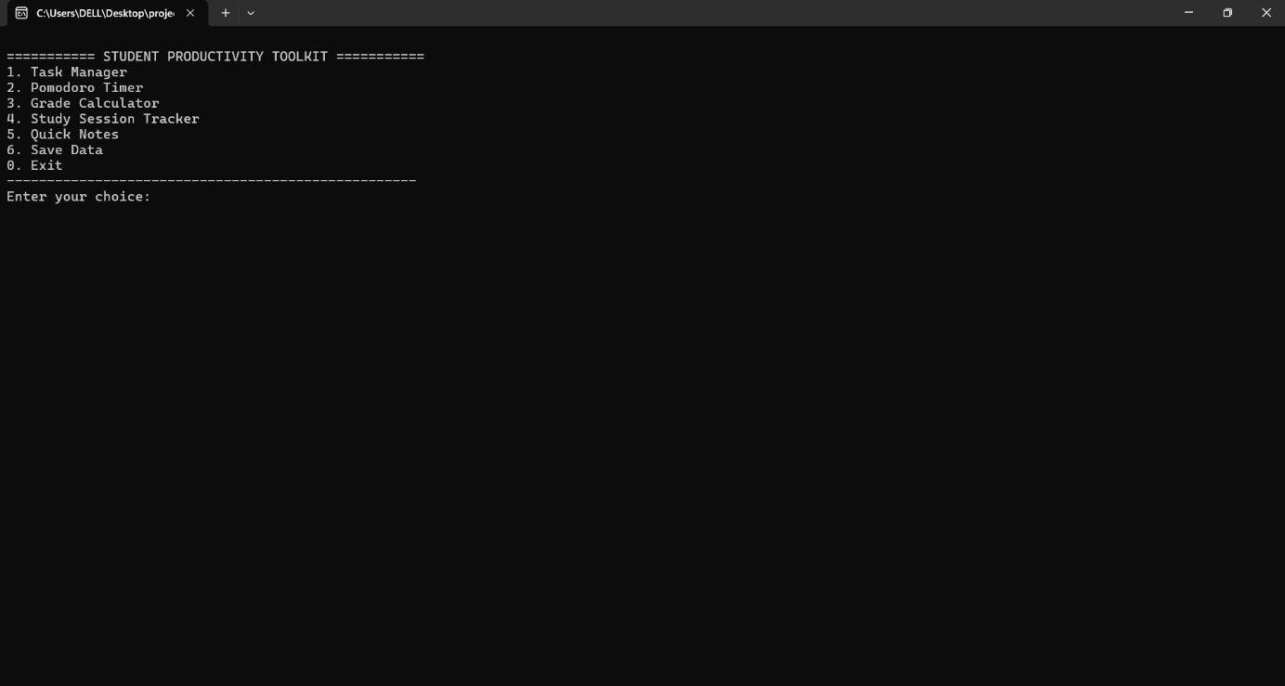
STEP-2:

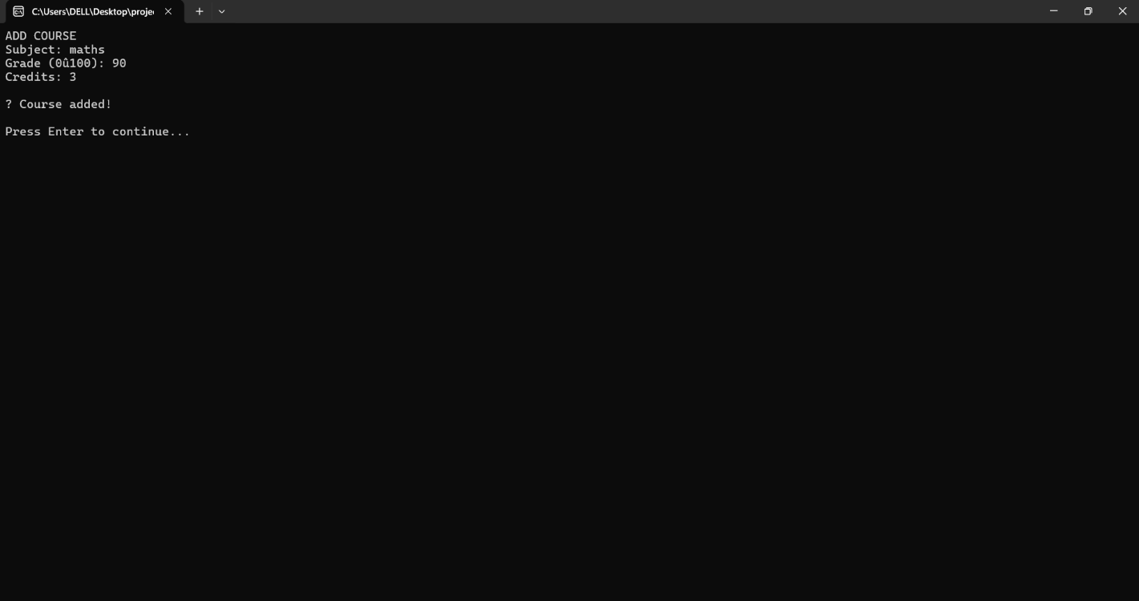

STEP-3: